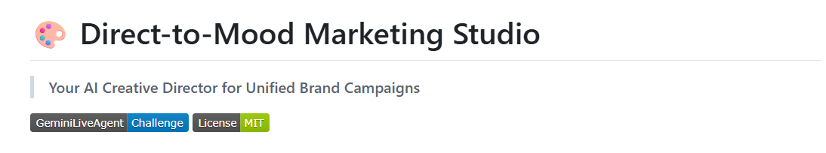
Built for the #GeminiLiveAgentChallenge

Project Summary
Features and functionality
Direct-to-Mood Marketing Studio is an AI-powered “Creative Director” that generates a complete, cohesive marketing campaign in a single step. A user describes their business and selects one of six moods (Elegant, Energetic, Minimal, Warm, Dramatic, Playful), and the app produces four tightly interlinked assets:
- Hook copy – short headline/opening text
- Hero visual prompt – highly detailed image prompt (lens, lighting, composition, color palette)
- Storytelling/value prop copy – narrative that deepens the brand story
- Video ad prompt – 10-second video specification with shots, transitions, and mood

All four assets are generated together to keep tone, visual style, and mood consistent, and the UI lets you copy each asset or export the full set. The interface is responsive, accessible, and highly polished, with glassmorphism styling, animations, and keyboard/screen-reader support.

Technologies used
- Frontend:
- React 18 (standalone, via CDN + Babel Standalone for in-browser JSX)
- Tailwind CSS + custom CSS for layout, gradients, and glassmorphism
- Google Fonts (`Outfit`, `Crimson Pro`) for typography
- Backend:
- Node.js 18+, Express for routing and serving the SPA
- Axiosfor HTTP calls to the AI API
- dotenv for environment configuration, cors for CORS control
- AI / Cloud:
- Google Gemini (Generative Language API `v1beta`) with a model fallback chain
(`gemini-2.5-flash` → `gemini-2.0-flash` → `gemini-2.0-flash-lite`)
- Google Cloud Run as the main containerized deployment target
- Vercel as an additional global edge deployment
- Tooling / Dev:
- `nodemon` for local development autoreload
- Docker + `Dockerfile` for containerization
- `vercel.json`, `app.yaml`, `deploy-gcp.ps1` for multi-target deployment

Other data sources used
The primary “data source” is the Gemini API, which produces structured JSON based on a carefully engineered system prompt and schema. There is no external database; user input and AI responses are ephemeral. The app does not store user data or integrate with third-party analytics—everything is request/response in memory. For fonts and styling, it uses Google Fonts and CSS frameworks via CDN, but there are no business-domain datasets beyond the user’s own input.

Findings and learnings
- Interleaving assets in a single AI call is critical for brand cohesion: by generating hook, image prompt, storytelling, and video prompt together, Gemini can reuse the same mood vocabulary, lighting, and color motifs across all assets, which is much harder if you call the model separately for each piece.
- A strict JSON schema dramatically improves reliability: enforcing fields like `type`, `content`, and `styling_notes` makes the UI stable and simplifies error handling and parsing.
- The UI/UX work (glassmorphism, motion, accessibility, responsive layout) matters as much as the model quality—users perceive the tool as “professional” and “ready for clients” because of the overall design polish, not just the AI output.
- Deploying to multiple platforms (Cloud Run + Vercel) is straightforward when you keep the app as a small Node/Express server plus a static React frontend; having dedicated configs (`Dockerfile`, `vercel.json`, `deploy-gcp.ps1`, `app.yaml`) makes this repeatable.
- From a workflow perspective, the project shows how a typical multi-tool AI marketing flow (ChatGPT + Midjourney + Runway + manual coordination) can be compressed into a single, fast, opinionated product, and that the biggest productivity gains come from removing context switching and design inconsistency, not just from “faster text generation.”

Proof of Google Cloud Deployment
1. In my Google Cloud Console → Cloud Run
- Show the `marketing-studio` service in the Cloud Run services list.
- The recording will clearly display: service name, Status: Active, Region: `europe-west1`, and the public URL (`https://gcloud-830001350094.europe-west1.run.app`).

2. Open the service details page
- Show the Revisions/ Details tab with the current revision, container image, and environment variables panel (proving it’s a Cloud Run service using my container).
- Switch to the Logs tab and scroll briefly to show recent logs from the Node/Express server (startup logs and request logs).

3. Hit the live backend from the browser
- In a new browser tab, open `https://gcloud-830001350094.europe-west1.run.app`.
- Use the UI to submit a real request (enter business description + mood → click “Generate Campaign”).
- Show the campaign results appearing in the frontend while the Cloud Run logs update in the console, proving the live traffic is going through the Cloud Run backend.

This recording demonstrates that the project’s backend is deployed and actively running on Google Cloud Run, handling real requests in production.

Secondary proof (code-level evidence – option 2,)
As additional proof, the GitHub repo [`kjelili/Marketing-Studio`](https://github.com/kjelili/Marketing-Studio) contains multiple configuration files that show direct integration with Google Cloud services:
- `Dockerfile` – builds a container image suitable for Cloud Run.
- `app.yaml` – configuration for deployment on Google App Engine (alternative GCP path).
- `deploy-gcp.ps1` and `DEPLOY_GCP.md` – scripted and documented deployment to Google Cloud Run using `gcloud run deploy`.
- `server.js` – Node/Express backend that calls the Google Gemini API (Generative Language API v1beta) using an API key provided via environment variables, demonstrating use of Google’s GenAI services from within a GCP-hosted backend.
Together, the screen recording plus these GCP-specific deployment/config files provide clear, verifiable proof that the backend is running on Google Cloud.

Live Demo:
→ demo-video.mp4 (located in the GitHub folder)
→ demo-video.html (located in the GitHub folder)

Architecture Diagram
Here’s a clear end-to-end view of the system, showing how Gemini connects to the backend and frontend:
